<html>

<head>

<title>Javascript</title>

<style>

body {

background-image: url('img.jpg');

background-repeat: no-repeat;

background-attachment: fixed;

background-size: cover;

}

#a{

border: 15px solid purple;

width: 50%;

height: 50%;

text-align: center;

}

form {

background: grey;

margin: 0 auto;

width:250px;

}

p{

font-size:20px;

text-decoration: underline;

}

input{

background: green;

}

.button{

background-color: green;

padding: 20px;

border-radius: 50%;

}

</style>

</head>

<body >

<form id="a">

<h2>Payroll Report</h2>

<label><u>Insert hourly rate:</u></label>

<input id="rate" type="text" maxlength="5"><br><br>

<label><u>How many hours:</u></label>

<input id="hours" type="text" maxlength="5"><br><br>

<button class="button" type="button" onclick="changeContent()">Calculate</button>

<p id ="tp"></p>

<p id ="gp"></p>

<p id ="d"></p>

</form>

</body>

</html>

<script>

function changeContent(){

var total, d;

var x = document.getElementById("rate").value;

var y = document.getElementById("hours").value;

if(y > 60 || y < 20)

{

alert("Hours must be between 20 and 60");

}

else

{

if (y > 40)

{

var e = (y-40)\*0.05;

total = x \* y + e;

}

else

{

total = x \* y;

}

if(x < 25)

{

d = total \* 0.05;

}

else

{

d = total \* 0.07;

}

document.getElementById("gp").innerHTML = 'Gross Pay: ........ ' + total + '$';

document.getElementById("d").innerHTML = 'Deductions: ........ ' + d + '$';

document.getElementById("tp").innerHTML = 'Total Pay: ........ ' + (total - d) + '$';

}

}

</script>

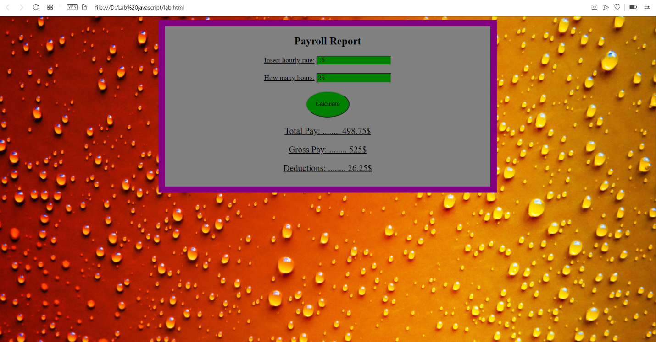

*Picture that I used*

**